Revision-March 2020: Comparative and Superlative adjectives

1) Read and match
b
c
d
e

Molly
a
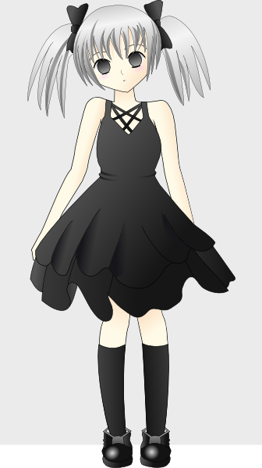
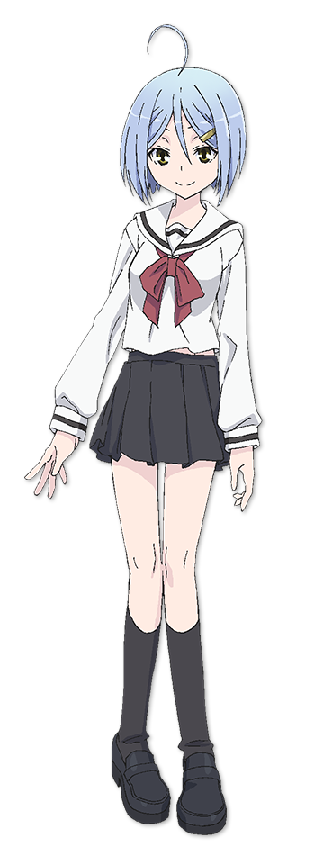


Jane
20€€
50€
35€
15€
€
40€
Sarah
Sarah is taller than Jane, Mary and Molly, but Ann is taller than Sarah.
Molly is fatter than Ann, Sarah and Mary, but Jane is fatter than Molly.
Mary’s hair is longer than Molly’s hair, Ann’s hair and Jane’s hair, but Sarah’s hair is longer than Mary’s hair.
Ann’s shoes are more expensive than Sarah’s shoes, Molly’s shoes and Jane’s shoes, but Mary’s shoes are more expensive than Ann’s shoes.

Mary

Ann
d

2) Write the adjectives.
1. __hot______ hotter
2. ___________ lovelier
3. ___________ more interesting
4. ___________ the happiest
5. ___________ earlier
6. ___________ drier
7. ___________ the most famous
8. ___________ friendlier
9. ___________ fatter
10. __________ more exciting
3) Complete the sentences using the words below and is or are.

1. France ________is bigger _______________ than Switzerland.
2. Gold _______________________________ than paper.
3. Sharks ______________________________than dolphins.
4. Chinese _____________________________than English.
5. June and July________________________ than April and May.
6. A funfair ____________________________than school.
7. Vegetables ___________________________than sweets.

big exciting dangerous heavy healthy hot difficult

4) Underline the correct word.
1. Football is more/the most exciting than baseball.
2. Winter is a cold/the colder season.
3. Apples are more/ the most useful than cakes.
4. My sister is heavier/the heaviest than me, but my father is heavier/the heaviest in my family.
5. Adam is better/ the best than Sam at tennis, but John is better/the best tennis player in our class.
6. The weather yesterday was worse/bad than last week, but the weather today is the worse/the worst weather this year.
7. Bicycles are the cheapest/cheaper form of transport, but they are also the slowest/ slower than cars and planes.

5) Put the words in order to make sentences.
1. thinks / is / than / Maths / She / Science / worse
_______________________________________________
2. best / in / Mark / the / our / is / singer / class
_______________________________________________
3. the / day / The / my / most / exciting / birthday / is / in / year. _____________________________________
______________________________________________
4. elephants / smaller / Mice / and / are / tigers / than
_______________________________________________
5. youngest / is / in / the / Mary / their / person / family
_______________________________________________
6. are / than / Dolphins / intelligent / hippos / more
_______________________________________________

KEY

Ex.1) Mary - a Sarah - b Jane - c Ann - d Molly - e

Ex. 3
2. is heavier
3. are more dangerous
4. is more difficult
5. are hotter
6. is more exciting
7. are healthier

Ex. 4)
2. a cold
3. more
4. heavier; the heaviest
5. better; the best
6. worse; the worst
7. the cheapest; slower

Ex. 5)
1. She thinks Maths is worse than Science.
2. Mark is the best singer in our class.
3. The most exciting day in the year is my birthday.
4. Mice are smaller than tigers and elephants.
5. Mary is the youngest person in their family.
6. Dolphins are more intelligent than hippos.

