Surname:
Name:
Form:
Anglais
Révisions de première année
Grammar

1 |  | Relie les questions aux réponses.
0 | Is Kaka a footballer? |  | ..... | Yes, you are.
1 | Are you British? |  | ..... | No, it isn’t.
2 | Am I a student? |  | ..... | No, I’m not.
3 | Is it 6 o’clock now? |  | ..... | Yes, she is.
4 | Is Angelina Jolie an actress? |  | ..... | No, he isn’t.
5 | Is Rafael Nadal an actor? |  | 0 | Yes, he is.

___/5 marks

- Si tu as besoin d'aide, va voir dans l'unité 1 de ton cours.

2 |  | Complète les phrases avec la forme correcte du verbe "to be". Il peut s'agir de la forme positive, négative ou interrogative.
0 | A: Is John from the USA?  B: No, he isn’t.
1 | A: ............... you from Barcelona?  B: Yes, I am.
2 | A: Are you French?  B: I’ ............... French. I’m Spanish.
3 | A: What’............... your teacher’s name?  B: Her name is Mrs Jones.
4 | A: ............... this your book?  B: No, it isn’t.
5 | A: Are you a student?  B: Yes, I ............... .

___/5 marks

- Si tu as besoin d'aide, va voir dans l'unité 1 de ton cours.

3 |  | - Écris l'opposé du verbe souligné. (La forme affirmative devient négative et vice versa).  - Attention, si le verbe est contracté, maintient cette forme.  - Suis l'exemple
0 | We’re in a band.  We aren’t in a band.
1 | Bob and Sarah are from England.  Bob and Sarah .......... from England.
2 | We aren’t at school now.  We’ .......... at school now.
3 | You aren’t my friends.  You’ .......... my friends.
4 | They’re good tennis players.  They .......... good tennis players.
5 | You’re from Switzerland.  You .......... from Switzerland.

___/5 marks

- Si tu as besoin d'aide, va voir dans l'unité 1 de ton cours.

4 |  | Complète les phrases avec la forme corecte de "to be".
0 | They aren’t from Brazil. They’re from Portugal.
1 | No, we .......... in a band. .......... you?
2 | We .......... singers and we don’t like music!
3 | .......... they your friends?
4 | She’ .......... a drummer in a new band.
5 | We’ .......... from London and we’ .......... English teachers.
___/5 marks
- Si tu as besoin d'aide, va voir dans l'unité 1 de ton cours.

5 |  | Tous les déterminants possessifs soulignés sont incorrectes. Corrige-les et écris tes réponses sur les pointillés.
0 | That’s my father. Her name is Harry. |  | His
1 | We live in Manchester. Their house is very nice. |  | ...............
2 | Here are my grandparents. His names are Tom and Amanda. |  | ...............
3 | I have a lot of friends. Our best friend is Amy. |  | ...............
4 | Maria doesn’t like its name. |  | ...............
5 | When do you do our homework? |  | ...............

___/5 marks

6 |  | Complète les phrases avec le déterminant possessif qui convient.
0 | You live with your grandparents, don’t you?
1 | I’m Paul and this is .......... sister, Sally.
2 | Jack doesn’t like .......... new school.
3 | We love .......... new dog, Jelly.
4 | I like that cat. What’s .......... name?
5 | Claudia and Ellie don’t like .......... brothers!

___/5 marks

- Si tu as besoin d'aide, va voir dans l'unité 2 de ton cours (possessive pronouns - les déterminants possessifs).

7 |  | Souligne la bonne réponse.
0 | There are / is three banks near here.
1 | Are / Is there a supermarket on the High Street?
2 | There are / aren’t any bookshops in my street.
3 | There isn’t / aren’t a park here.
4 | Aren’t / Isn’t there a library near the market?
5 | Is / Are there any cinemas in the city centre?

___/5 marks

- Si tu as besoin d'aide, va voir dans l'unité 1 de ton cours (synthèse sur "to be").

8 |  | Relie les questions à leurs réponses.
0 | Why are you so happy? |  | .... | Because he hasn’t got any friends.
1 | Why does Lisa go to the Internet café every day? |  | .... | Because they don’t like sport.
2 | Why doesn’t Peter go out after school? |  | .... | Because she’s got friends online.
3 | Why does Jessica like English so much? |  | .... | Because she’s got a great teacher.
4 | Why haven’t your parents got a car? |  | .... | Because they don’t like driving.
5 | Why don’t your brothers play football? |  | 0 | Because I’ve got a new bicycle.

___/5 marks

9 |  | Complète les phrases à l'aide de la correcte forme de "have got" (positive, négative ou interrogative)
0 | We’ve got two cats and three rabbits at home.
1 | David .................... a DVD player because he doesn’t like watching films.
2 | We’.................... a really nice French teacher.
3 | .................... Laura .................... any brothers or sisters?
4 | I’.................... lots of DVDs because I love films.
5 | No, I .................... got your English dictionary.
___/5 marks

- Si tu as besoin d'aide, va voir dans l'unité 2 de ton cours (synthèse sur "to have got").

10 |  | Complete the sentences.
0 | Jose can’t speak English very well because he’s a beginner.
1 | ............... you ride a bicycle?
2 | Sally is not musical. She ............... play the guitar.
3 | We can play volleyball but we ............... play football.
4 | My grandmother ............... use a computer because she’s very old and doesn’t understand technology!
5 | I was born in Paris. I ............... speak French.

___/5 marks

- Si tu as besoin d'aide, va voir dans l'unité 4 de ton cours (synthèse sur "can/can't").

11 | Ecris des phrases à l'aide des éléments imposés. Suis l'exmple.  + = phrase affirmative  - = phrase négative

0 | Clare / play tennis (+) / play volleyball (-)  Clare can play tennis but she can’t play volleyball.
1 | Antonio and Carlo / play football (+) / ski (-)  Antonio and Carlo ........................................ .
2 | I / ride a bicycle (+) / ride a horse (-)  I ........................................ .
3 | My parents / ski (+) / snowboard (-)  My parents ........................................ .
4 | David / speak French (+) / speak German (-)  David ........................................ .
5 | We / sing (+) / play the guitar (-)  We ........................................ .

___/5 marks
- Si tu as besoin d'aide, va voir dans l'unité 4 de ton cours (synthèse sur "can/can't").

Vocabulary

12 |  | Ecris le nom des pays.
0 | S p a i n
1 | T .... .... .... .... y
2 | J .... .... .... n
3 | B .... .... .... .... l
4 | C .... .... .... .... a
5 | P .... .... .... .... .... .... l

___/5 marks

13 |  | Ecris le nom des nationalités en lien avec les pays proposés.
0 | Britain |  | British
1 | Belgium |  | ....................
2 | Italy |  | ....................
3 | China |  | ....................
4 | Poland |  | ....................
5 | Spain |  | ....................

___/5 marks

14 |  | Complète avec le nom de pays ou nationalité adéquat.
0 | Anna is Polish. She’s from Poland.
1 | Georg is Swiss. He’s from .................... .
2 | Akiko is Japanese. She’s from .................... .
3 | Olga is Russian. She’s from .................... .
4 | Jeff is Canadian. He’s from .................... .
5 | Michelle is French. She’s from .................... .

___/5 marks

15 |  | Complète les phrases avec la nationalité correspondant au pays entre parenthèse.
0 | Kaka is a famous Brazilian footballer. (Brazil)
1 | ............... is a very difficult language. (Portugal)
2 | ............... chocolate is very famous. (Belgium)
3 | ............... pizza is good! (Italy)
4 | Do you like ............... food? (China)
5 | Istanbul is a ............... city. (Turkey)

___/5 marks
- Si tu as besoin d'aide, consulte l'unité 1 de ton cours.

16 |  | Les phrases suivantes expriment-elles quelque chose de positif (+) ou négatif (-)? Ecris + ou -.
0 | Coldplay are my favourite band. |  | +
1 | Volleyball is a fantastic sport. |  | ..........
2 | Horses are wonderful animals. |  | ..........
3 | Classical music is awful. |  | ..........
4 | New York is a great city. |  | ..........
5 | English grammar is terrible! |  | ..........

___/5 marks
- Si tu as besoin d'aide, consulte l'unité 2 de ton cours.

17 |  | Ecris les mots dans l'ordre pour écrire une phrase correcte.
0 | a / city / Rome / fantastic / is |  | Rome is a fantastic city.
1 | sport / football / awful / an / is |  | ........................................
2 | film / ‘Pretty Woman’ / is / a / great |  | ........................................
3 | fantastic / Belgian / is / chocolate |  | ........................................
4 | friend / you’re / wonderful / a |  | ........................................
5 | is / coffee / English / terrible |  | ........................................

___/5 marks
- Si tu as besoin d'aide, consulte l'unité 2 de ton cours.

18 | Observe l'arbre généalogique de Jenny et note les liens de parenté.
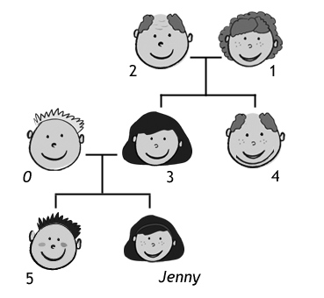
0 |  | father
1 |  | ....................
2 |  | ....................
3 |  | ....................
4 |  | ....................
5 |  | ....................

___/5 marks
- Si tu as besoin d'aide, consulte l'unité 2 de ton cours.

19 | Complète les phrases.
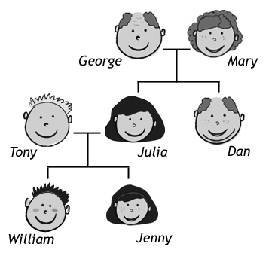
0 |  | Dan is George’s son.
1 |  | Jenny is William’s .................... .
2 |  | Julia is Tony’s .................... .
3 |  | Julia is Mary’s .................... .
4 |  | William is Jenny’s .................... .
5 |  | Tony is Julia’s .................... .

___/5 marks
- Si tu as besoin d'aide, consulte l'unité 2 de ton cours.

20 |  | Ecris ces nombres en chiffres.
0 | a hundred and twenty |  | 120
1 | two hundred and ten |  | ...............
2 | three hundred and forty |  | ...............
3 | four hundred and sixty |  | ...............
4 | a thousand |  | ...............
5 | two thousand five hundred |  | ...............

___/5 marks

21 |  | Ecris ces nombres en toutes lettres.
0 | 130 |  | a hundred and thirty
1 | 250 |  | ........................................
2 | 380 |  | ........................................
3 | 512 |  | ........................................
4 | 2,000 |  | ........................................
5 | 3,700 |  | ........................................

___/5 marks

- Si tu as besoin d'aide, consulte l'unité 1 de ton cours.

22 |  | Ecris les jours de la semaine en anglais .  Note-les dans l'ordre.  N'oublie pas la majuscule.
0 | Sunday, Monday
1 | .........................
2 | .........................
3 | .........................
4 | .........................
5 | .........................

___/5 marks

- Si tu as besoin d'aide, consulte l'unité 0 (Welcome Unit) de ton cours.

 | 23 | Lis les adjectifs provenant de la boite.  Ecris chaque adjectif sous l'image à laquelle il correspond.
bored angry excited scared happy sad
 | 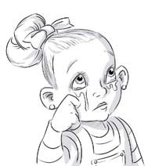 |  |  | 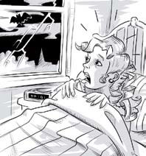
 | sad |  | ......................... | .........................
 | 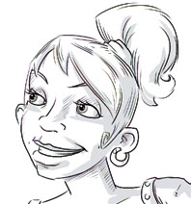 |  | 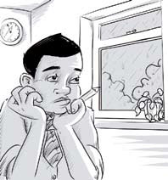
 | ......................... |  | ......................... | .........................

___/5 marks

- Si tu as besoin d'aide, consulte l'unité 2 de ton cours.

24 |  | Souligne l'adjectif qui convient.
0 | Bill’s excited / worried because it’s his birthday today.
1 | Don’t shout at me! Why are you so scared / angry ?
2 | I’m bored / scared because this film isn’t interesting.
3 | I’m very happy / sad because we’ve got a new cat.
4 | Jan is excited / confused because he doesn’t understand the question.
5 | Robert is worried / bored because he doesn’t know where his mobile phone is.

___/5 marks

- Si tu as besoin d'aide, consulte l'unité 2 de ton cours.

25 | De quel sport s'agit-il? Remets les lettres dans l'ordre pour former le mot.

0 | stinen | tennis
1 | wgnismim | .........................
2 | sahctliet | .........................
3 | bygru | .........................
4 | blelyalvol | .........................
5 | stimgascyn | .........................

___/5 marks
- Si tu as besoin d'aide, consulte l'unité 4 de ton cours.

 | 26 | Quels sont ces sports? Ecris ces mots sous les images correspondantes.
skiing cycling snowboarding playing football horse riding playing basketball
 | skiing |  | ......................... | .........................
 | ......................... |  | ......................... | .........................

___/5 marks

27 |  | Quels sont ces sports? Complète les mots.
0 | t e n n i s
1 | s ... ... ... ... ... ... ... ... ding
2 | r ... ... ... ... ... ... ... ... ding
3 | r ... ... ... y
4 | v ... ... ... ... ... ... ... ... l
5 | g ... ... ... ... ... ... ... ... s

___/5 marks

- Si tu as besoin d'aide, consulte l'unité 4 de ton cours.

28 | Quels sont ces sports? Note les mots sous les images.
skiing |  | ......................... | .........................
......................... |  | ......................... | .........................

___/5 marks

- Si tu as besoin d'aide, consulte l'unité 4 de ton cours.

 | 29 |  |  | Annote le dessin. Utilise les mots qui proviennent de l'encadré.
living room bathroom garden hall bedroom kitchen
 | 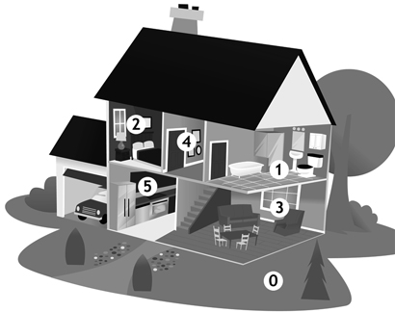
 |  | 0 | garden
 |  | 1 | ....................
 |  | 2 | ....................
 |  | 3 | ....................
 |  | 4 | ....................
 |  | 5 | ....................

___/5 marks

- Si tu as besoin d'aide, consulte l'unité 3 de ton cours.

30 |  | Complète les phrases avec le nom de meuble ou d'appareil qui convient.  La première lettre de chaque mot t'a été donnée.
0 | There are four chairs around the kitchen table.
1 | We’ve got a great s.................... in the bathroom. The water is always warm.
2 | Dad always sits in his old a.................... when he watches television.
3 | Please put the milk and butter in the f.................... .
4 | Don’t touch the c.................... because it’s very hot.
5 | Can you close the w.................... , please. It’s very cold in here now.

___/5 marks

- Si tu as besoin d'aide, consulte l'unité 3 de ton cours.

31 | Souligne la bonne réponse.

0 | New Year’s Day is in ____.
 | a) July | b) January | c) June
1 | There are 28 days in ____.
 | a) March | b) December | c) February
2 | July, ____, September.
 | a) June | b) August | c) October
3 | ____ comes after winter.
 | a) Spring | b) Autumn | c) Winter
4 | Halloween is at the end of _______.
 | a) October | b) November | c) December
5 | In Australia it’s _______ in July.
 | a) summer | b) spring | c) winter

___/5 marks

- Si tu as besoin d'aide, consulte l'unité 0 (Welcome Unit) de ton cours.

Reading

32 | Lis le texte au sujet de la classe de Lucia .  Décide si les propositions sont vraies (V) ou fausses (F).  Ecris V ou F.
Hi Alex
How are you?! I’m fine. I’m at school in London now and it’s really great. I’m in a class with ten students. We’re from lots of different countries.
Olga’s from Russia. She’s fifteen and I like her very much. She’s my best friend in the class. Her brother Andrej is also in our class. He’s a great tennis player and I like him too. Isabella’s Spanish and her English is very good. Her favourite band is Coldplay so we like the same music!! Marek’s from Poland. I don’t like him very much. He isn’t very nice.
Marcelo’s from Italy. We’re from the same city – Roma! His English is fantastic. Akiko is a Japanese girl. She’s sixteen and she’s from Tokyo. We’re in the same family here in London. There’s a Chinese girl in our class. Her Chinese name is very difficult so her English name is Lucy. And then Lisa is from Switzerland. She’s only fourteen and she’s from Basel. Her favourite language is French, not English! And finally Fred … he’s from Belgium. His best friend in the class is Andrej.
Please write soon.
Love
Lucia x
0 |  | Lucia is English. | F
1 |  | Lucia’s school is fantastic. | ......
2 |  | Olga’s brother is Russian. | ......
3 |  | Isabella’s English is awful. | ......
4 |  | Marek is Lucia’s friend. | ......
5 |  | Marcelo’s Italian. | ......
6 |  | Akiko’s 15. | ......
7 |  | Lucy is from China. | ......
8 |  | Lisa is French. | ......
9 |  | Lisa’s favourite language is English. | ......
10 |  | Fred’s best friend is Russian. | ......

___/10 marks

Writing

33 | Lis le texte au sujet de Louisa. Ecris un texte similaire dans lequelle tu te présentes.  Les informations en bleu sont celles qui doivent changer en fonction de toi.
Hi! I’m Louisa. I’m 15. I’m English and I’m from London. My address is 7 Park Drive, Hampstead, London. My mobile phone number is 07743 629418. I like tennis and volleyball but I don’t like football. My favourite actress is Julia Roberts. She’s from America.

34 | Lis le texte au sujet du frèred'Eva.  Puis, rédige quelques lignes au sujet d'un membre de ta propre famille.  Ecris au sujet de:  - son identité  - son physique et son caractère  - son métier  - ses (in)capacités - en employant can et can't
My brother’s name is Harry and he’s fifteen. I think he’s good-looking but I don’t tell him! He’s got short dark hair. It’s usually straight but it gets wavy when it’s wet. He’s quite tall with long legs, so he’s very good at volleyball! He’s got grey eyes and a nice smile and all my friends really like him. I like him too. He’s a good brother and we sometimes go out together at the weekends. He likes music and he can play the guitar very well. His favourite band is the Kaiser Chiefs. He can cook delicious pasta but he can't make a sandwich! That's crazy, isn't it?

Listening

35 | Ecoute la jeune fille parler de ce qu'elle sait faire ou ne pas faire.  Complète le tableau suivant en français.  Piste audio: Can & can't

Sait faire | Ne sait pas faire

