
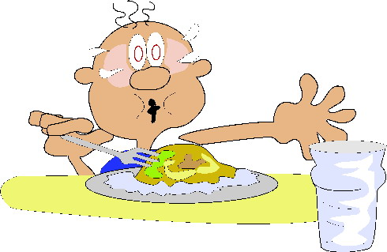
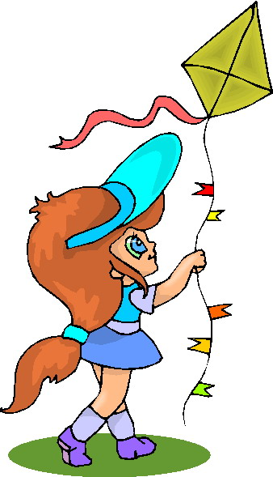
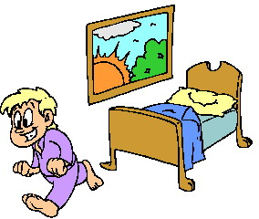

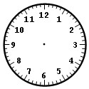

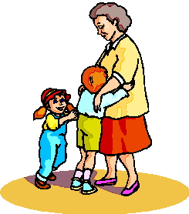
___________ ____________ ______________ ____________
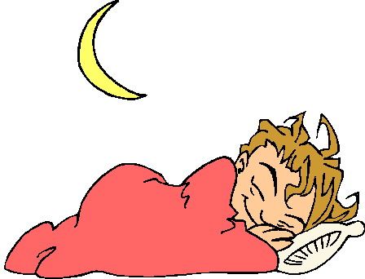



___________ ___________ ____________ ______________
get dressed get up play go to bed
have breakfast visit do homework eat (...)

→Write about your best friend’s day and use adverbs of frequency. Then draw the hands into the clocks. For example:he usually gets up at six in the mornings. He never has a sandwich for breakfast.






