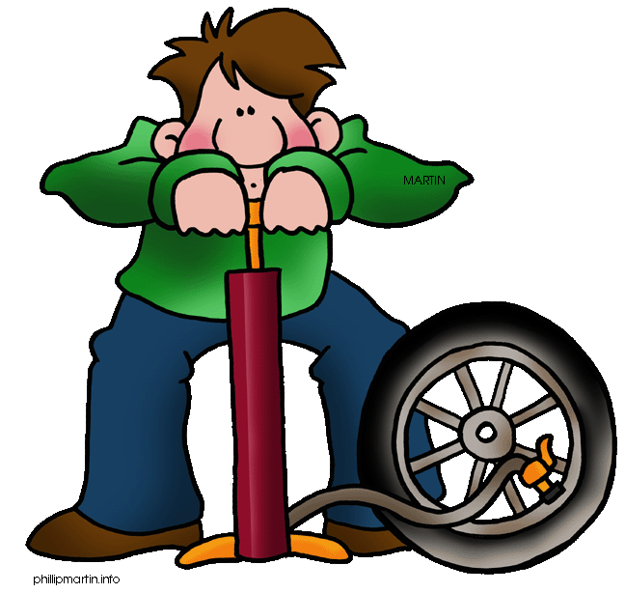

FILL IN THE BLANKS WITH THE CORRECT VERBAL FORM.
1.- I won’t finish it on time unless you………… (help) me.
2.-If I had another puncture, I …………. (repair) it.
3.-If they were Japanese, they ……….. (not speak) Chinese.
4.-If I saw a big spider in my house, I ………… (scream) loudly.
5.-The hijackers would threaten us if they ………. (have) a bomb.
6.-You would have arrived earlier if you ………….. (catch) a taxi.
7.-Eric ………… (win) the race if he had trained better.
8.-Kevin will return to the office if his boss ………….. (tell) him so.
9.-His mother would let him go to the party if he ………. (get) good marks at the exam.
10.-Yoana’s friend would have enjoyed the concert if she …..… (go)
11.-If you see John at the pub, ………….(remind) him to call me.
12.-The government will increase the taxes if they ……. ……….. (think) it is necessary.
13.-Bernard won’t cross the road until it ……….. (get) green.
14.-Helen ………. (catch) a cold if she doesn’t wear a coat.
15.-If the pain returned, you ……….. (phone) the doctor.
16.-Sonia would have breakfast with us if she ………… (get)up on time.
17.- I ………… (wash) the dishes if I had had enough time.
18.-My client would have accepted it if I …………. (be) more generous.
19.-The film director won’t make the film unless the famous actress ………….. (sign) the contract.
20.-If I weren’t so shy, I ………..… (ask) the teacher a question.
21.-They wouldn’t have drowned if they …..…… (wear) a lifejacket.
22.-Mr Potter would publish the novel if it …..…..(not be)interesting.
23.-He would be rich if he …….. (win) the lottery.
24.-You have to fill in this form if you………. (need) a visa.
25.- If she buys the paint, I …….. (do)it for you.

Conditionals- Mixed types

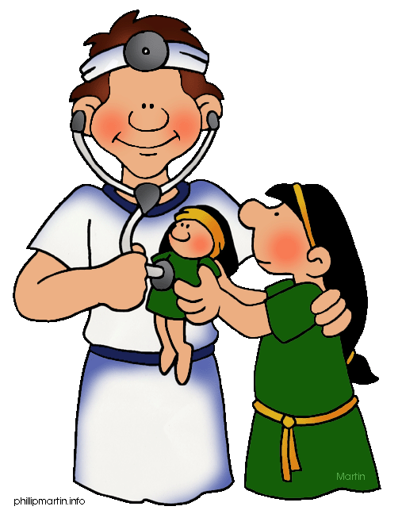



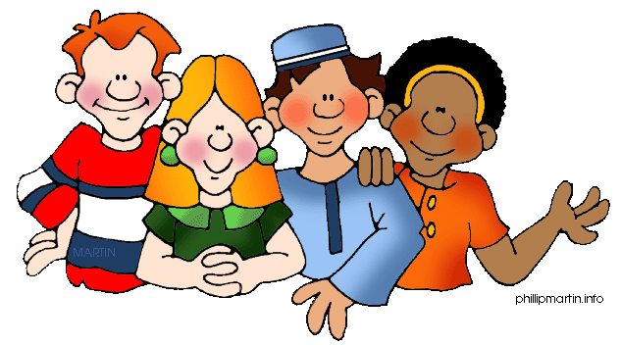

1.- I won’t finish it on time unless you help me.
2.-If I had another puncture, I would repair it.
3.-If they were Japanese, they wouldn’t speak Chinese.
4.-If I saw a big spider in my house, I would scream loudly.
5.-The hijackers would threaten us if they had a bomb.
6.-You would have arrived earlier if you had caught a taxi.
7.-Eric would have won the race if he had trained better.
8.-Kevin will return to the office if his boss tells him so.
9.-His mother would let him go to the party if he gets good marks at the exam.
10.-Yoana’s friend would have enjoyed the concert if she had gone.
11.-If you see John at the pub, remind him to call me.
12.-The government will increase the taxes if they think it is necessary.
13.-Bernard won’t cross the road until it gets green.
14.-Helen will catch a cold if she doesn’t wear a coat.
15.-If the pain returned, you would phone the doctor.
16.-Sonia would have breakfast with us if she got up on time.
17.- I would have washed the dishes if I had had enough time.
18.-My client would have accepted it if I had been more generous.
19.-The film director won’t make the film unless the famous actress signs the contract.
20.-If I weren’t so shy, I would ask the teacher a question.
21.-They wouldn’t have drowned if they had worn a lifejacket.
22.-Mr Potter would publish the novel if it weren’t interesting.
23.-He would be rich if he won the lottery.
24.-You have to fill in this form if you need a visa.
25.- If she buys the paint, I will do it for you.

