Grammar

1 |  | Match the questions with the answers.
0 | Is Kaka a footballer? |  | ..... | Yes, you are.
1 | Are you British? |  | ..... | No, it isn’t.
2 | Am I a student? |  | ..... | No, I’m not.
3 | Is it 6 o’clock now? |  | ..... | Yes, she is.
4 | Is Angelina Jolie an actress? |  | ..... | No, he isn’t.
5 | Is Rafael Nadal an actor? |  | 0 | Yes, he is.

___/5 marks

2 | Complete the questions. Use the words in the box.
Who Where How What Where Where

0 | A: Where’s your school?  B: It’s in London.
1 | A: ............... old are you?  B: I’m seventeen.
2 | A: ............... ’s that woman?  B: It’s Queen Latifah!
3 | A: ............... ’s your name?  B: My name’s Joanna.
4 | A: ............... are you from?  B: I’m from Poland.
5 | A: ............... ’s your friend?  B: She’s at school.

___/5 marks

3 |  | Complete the sentences with the correct form of be.
0 | A: Is John from the USA?  B: No, he isn’t.
1 | A: ............... you from Barcelona?  B: Yes, I am.
2 | A: Are you French?  B: I’ ............... French. I’m Spanish.
3 | A: What’............... your teacher’s name?  B: Her name is Mrs Jones.
4 | A: ............... this your book?  B: No, it isn’t.
5 | A: Are you a student?  B: Yes, I ............... .

___/5 marks

4 |  | Write the questions.
0 | A: Where’s your school?  B: My school’s in Paris.
1 | A: .............................. ?  B: I’m sixteen.
2 | A: .............................. ?  B: My name’s Patrick.
3 | A: .............................. ?  B: Sally’s my best friend.
4 | A: .............................. ?  B: Marco’s from Italy.
5 | A: .............................. ?  B: I’m at school.

___/5 marks

5 |  | Write the opposite of the underlined words.
0 | We’re in a band.  We aren’t in a band.
1 | Bob and Sarah are from England.  Bob and Sarah .......... from England.
2 | We aren’t at school now.  We’ .......... at school now.
3 | You aren’t my friends.  You’ .......... my friends.
4 | They’re good tennis players.  They .......... good tennis players.
5 | You’re from Switzerland.  You .......... from Switzerland.

___/5 marks

6 |  | Complete the sentences with the correct form of be.
0 | They aren’t from Brazil. They’re from Portugal.
1 | No, we .......... in a band. .......... you?
2 | We .......... singers and we don’t like music!
3 | .......... they your friends?
4 | She’ .......... a drummer in a new band.
5 | We’ .......... from London and we’ .......... English teachers.

___/5 marks

7 |  | Complete the sentences. Use the present simple of the words in brackets.
0 | Paul and Stephen don’t live in a big house. (not live)
1 | Where ............... your sister ............... English? (study)
2 | My Dad ............... television every evening. (watch)
3 | Hannah ............... football. (not like)
4 | ............... you ............... Ben? (know)
5 | Barack Obama ............... two daughters. (have)

___/5 marks

8 |  | Correct the underlined word in each sentence.
0 | That’s my father. Her name is Harry. |  | His
1 | We live in Manchester. Their house is very nice. |  | ...............
2 | Here are my grandparents. His names are Tom and Amanda. |  | ...............
3 | I have a lot of friends. Our best friend is Amy. |  | ...............
4 | Maria doesn’t like its name. |  | ...............
5 | When do you do our homework? |  | ...............

___/5 marks

9 | Complete the sentences with the correct form of the words in the box.
live go work finish study know

0 | We live in a nice house.
1 | My brother ............... English and French at school.
2 | Where ............... your father ............... ?
3 | This lesson ............... at three o’clock.
4 | I’m sorry, I ............... the answer to this question.
5 | My sister ............... shopping every weekend!

___/5 marks

10 |  | Complete the sentences.
0 | You live with your grandparents, don’t you?
1 | I’m Paul and this is .......... sister, Sally.
2 | Jack doesn’t like .......... new school.
3 | We love .......... new dog, Jelly.
4 | I like that cat. What’s .......... name?
5 | Claudia and Ellie don’t like .......... brothers!

___/5 marks

11 |  | Underline the correct answer.
0 | I don’t like this / these chicken.
1 | These / This aren’t my oranges.
2 | I’d like to buy those / that cheese, please.
3 | Mmm. Those / These strawberries are delicious.
4 | Look at these / those eggs over there. They’re so brown!
5 | I don’t like this / these fruit. What is it?

___/5 marks

12 | Underline the correct answer.

0 | Mmm. ____ chips are delicious!
 | a) That | b) This | c) These
1 | Is ____ your dictionary?
 | a) this | b) these | c) those
2 | I don’t like ____ shoes in the window.
 | a) this | b) those | c) that
3 | I like ____ music. What’s the name of the band?
 | a) this | b) these | c) those
4 | Who’s ____ man over there with Sandra?
 | a) this | b) those | c) that
5 | Excuse me, ____ bread is very old.
 | a) those | b) that | c) this

___/5 marks

13 | Underline the correct sentence.

0 | a I watch hardly ever television.  b I hardly ever watch television.
1 | a Jack is never late for school.  b Jack never is late for school.
2 | a We often play football at the weekend.  b Often we play football at the weekend.
3 | a Mum always is tired in the evening.  b Mum is always tired in the evening.
4 | a My sister helps usually me with my homework.  b My sister usually helps me with my homework.
5 | a Jackie hardly ever is unhappy.  b Jackie is hardly ever unhappy.

___/5 marks

14 | Match an expression from A with an expression from B.

 | A |  | B
0 | on Monday, Wednesday and Friday | .... | once a week
1 | at 2 o’clock and at 10 o’clock | 0 | three times a week
2 | on Monday, Tuesday, Wednesday, Thursday, Friday, Saturday and Sunday | .... | twice an hour
3 | on Wednesdays | .... | every day
4 | at 10.15 and 10.45 | .... | once a year
5 | every July | .... | twice a day

___/5 marks

15 | Write the sentences.

0 | Paul / be / never / late  Paul is never late.
1 | John / not / usually / play tennis on Saturdays.  .............................................
2 | Sarah / hardly ever / go out in the evening.  .............................................
3 | We / not / often / go on holiday in July.  .............................................
4 | Mum / be / often / tired after work.  .............................................
5 | Tina / sometimes / work / at the weekend.  .............................................

___/5 marks

16 | Complete the second sentence so that it means the same as the first sentence.

0 | Pavel goes swimming on Monday, Wednesday and Friday.  Pavel goes swimming three times a week.
1 | I do my homework on Monday, Tuesday, Wednesday, Thursday, Friday, Saturday and Sunday.  I do my homework ......................... .
2 | Kate checks her emails at 8 o’clock and 3 o’clock.  Kate checks her emails ......................... .
3 | Mark goes swimming on Saturdays.  Mark goes swimming ......................... .
4 | We go on holiday in July and December.  We go on holiday ......................... .
5 | Mum texts me at 9 o’clock, 10 o’clock, 11 o’clock …!  Mum texts me ......................... !

___/5 marks

17 | Underline the correct answer.

0 | My birthday’s ____ the 23rd January.
 | a) in | b) on | c) at
1 | We always go to Spain ____ the summer.
 | a) in | b) on | c) at
2 | Our English lesson usually starts ____ 9 o’clock.
 | a) in | b) on | c) at
3 | Dad always plays football ____ Saturdays.
 | a) in | b) on | c) at
4 | My sister’s birthday is ____ March.
 | a) in | b) on | c) at
5 | I often go to the cinema ____ the weekend.
 | a) in | b) on | c) at

___/5 marks

18 |  | Complete the sentences with in, on or at.
0 | It’s my birthday on Tuesday.
1 | The film starts .......... 7 o’clock.
2 | We always go on holiday .......... the autumn.
3 | Tom’s party is .......... Saturday. Are you coming?
4 | I usually get up late .......... the weekend.
5 | School finishes .......... 10th July this year.

___/5 marks

Vocabulary

19 |  | Write the countries.
0 | S p a i n
1 | T .... .... .... .... y
2 | J .... .... .... n
3 | B .... .... .... .... l
4 | C .... .... .... .... a
5 | P .... .... .... .... .... .... l

___/5 marks

20 |  | Write the nationalities.
0 | Britain |  | British
1 | Belgium |  | ....................
2 | Italy |  | ....................
3 | China |  | ....................
4 | Poland |  | ....................
5 | Spain |  | ....................

___/5 marks

21 |  | Complete the sentences.
0 | Anna is Polish. She’s from Poland.
1 | Georg is Swiss. He’s from .................... .
2 | Akiko is Japanese. She’s from .................... .
3 | Olga is Russian. She’s from .................... .
4 | Jeff is Canadian. He’s from .................... .
5 | Michelle is French. She’s from .................... .

___/5 marks

22 |  | Complete the sentences. Use the words in brackets.
0 | Kaka is a famous Brazilian footballer. (Brazil)
1 | ............... is a very difficult language. (Portugal)
2 | ............... chocolate is very famous. (Belgium)
3 | ............... pizza is good! (Italy)
4 | Do you like ............... food? (China)
5 | Istanbul is a ............... city. (Turkey)

___/5 marks

23 | Write the words for Jenny’s family.
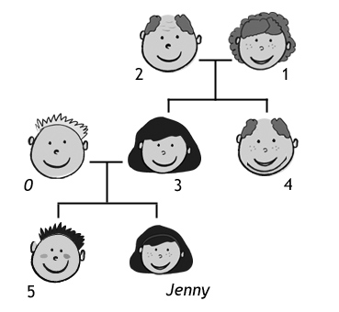
0 |  | father
1 |  | ....................
2 |  | ....................
3 |  | ....................
4 |  | ....................
5 |  | ....................

___/5 marks

24 | Complete the sentences.
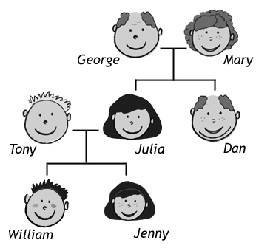
0 |  | Dan is George’s son.
1 |  | Jenny is William’s .................... .
2 |  | Julia is Tony’s .................... .
3 |  | Julia is Mary’s .................... .
4 |  | William is Jenny’s .................... .
5 |  | Tony is Julia’s .................... .

___/5 marks

25 |  | Write the numbers.
0 | a hundred and twenty |  | 120
1 | two hundred and ten |  | ...............
2 | three hundred and forty |  | ...............
3 | four hundred and sixty |  | ...............
4 | a thousand |  | ...............
5 | two thousand five hundred |  | ...............

___/5 marks

26 |  | Write the numbers.
0 | 130 |  | a hundred and thirty
1 | 250 |  | ........................................
2 | 380 |  | ........................................
3 | 512 |  | ........................................
4 | 2,000 |  | ........................................
5 | 3,700 |  | ........................................

___/5 marks

27 | What are these sports? Write the words in the correct order.

0 | stinen | tennis
1 | wgnismim | .........................
2 | sahctliet | .........................
3 | bygru | .........................
4 | blelyalvol | .........................
5 | stimgascyn | .........................

___/5 marks

 | 28 | What are the sports? Match the pictures with the words in the box.
skiing cycling snowboarding playing football horse riding playing basketball
 | skiing |  | ......................... | .........................
 | 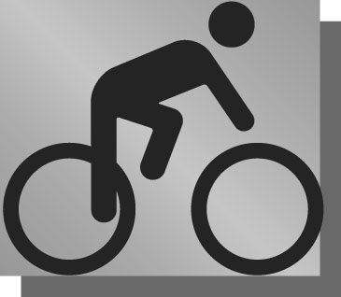
 | ......................... |  | ......................... | .........................

___/5 marks

29 |  | What are these sports? Complete the words.
0 | t e n n i s
1 | s ... ... ... ... ... ... ... ... ding
2 | r ... ... ... ... ... ... ... ... ding
3 | r ... ... ... y
4 | v ... ... ... ... ... ... ... ... l
5 | g ... ... ... ... ... ... ... ... s

___/5 marks

30 | What are the sports?
skiing |  | ......................... | .........................
......................... |  | ......................... | .........................

___/5 marks

Total: _________ / 150

