People often go to the supermarket with a list, but buy things that aren’t on the list. Why?
The next time you are in a supermarket, pay attention to what you see and smell. Usually fresh fruit and vegetables are near the entrance. Is there a reason for this? Yes, there is. Fresh food near the entrance makes people think all the items in the shop are fresh. Why is there a good smell of baking near the bread shelves? The bread is in plastic bags, but the smell (from bakery section) makes people feel hungry and then they buy more. And what is next to the checkout? How many bags of sugar or rice do you see there? How many eggs? None! This is the place for sweets and magazines. People stand in the queue, see the sweets and magazines and buy them, without thinking about how much money they are spending
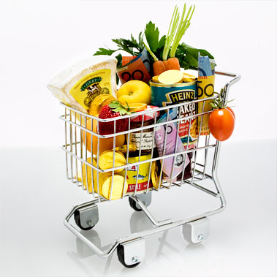

1.- How do you say it in your language?
- pay attention ___ 4. checkout ___
- items ___ 5. none! ___
- feel hungry ___ 6. without thinking ___

2.- Find the words in the text that mean:
- where you buy food and cleaning things door
- places to put things in order
- amount of coins and notes
3.- Give the opposite
- near (line 2) ___
- good (line 5) ___
- buy (line 7) ___
4.- Correct the mistakes in bold
- In a supermarket, the fresh fruit is usually near the checkout.
- The fruit is in plastic bags
- The smell near the bread makes people feel thirsty.
- There are sweets near the entrance.
- People buy eggs without thinking.
5.- Match A to B to complete the sentences about supermarkets.
- Rice and sugar a) has got a good smell
- Bread b) are near the checkout
- Fruit and vegetables c) are fresh
- Sweets d) aren’t near the checkout
6.- Answer these questions. Give full answers.
- Where are usually vegetables and fresh fruit in a supermarket? ……………………………………………………..
- Why? …………………………………………………….…………………………………………………….….…………………………………
- Why is the smell from the bakery section? …………………………………………………….………………………………….
- What are there near the checkout? …………………………………………………….…………………………………………….
7.- Make a list of ten items that you find in a supermarket and you use to clean.
The next time you are in a supermarket, pay attention to what you see and smell. Usually fresh fruit and vegetables are near the entrance. Is there a reason for this? Yes, there is. Fresh food near the entrance makes people think all the items in the shop are fresh. Why is there a good smell of baking near the bread shelves? The bread is in plastic bags, but the smell (from bakery section) makes people feel hungry and then they buy more. And what is next to the checkout? How many bags of sugar or rice do you see there? How many eggs? None! This is the place for sweets and magazines. People stand in the queue, see the sweets and magazines and buy them, without thinking about how much money they are spending
People often go to the supermarket with a list, but buy things that aren’t on the list. Why?

1.- How do you say it in your language?
- pay attention ___ 4. checkout ___
- items ___ 5. none! ___
- feel hungry ___ 6. without thinking ___

2.- Find the words in the text that mean:
- where you buy food and cleaning things
- door
- places to put things in order
- amount of coins and notes
3.- Give the opposite
- near (line 2) ___ far
- good (line 5) ___ bad
- buy (line 7) ___ sell
4.- Correct the mistakes in bold
- In a supermarket, the fresh fruit is usually near the checkout. entrance
- The fruit is in plastic bags. bread
- The smell near the bread makes people feel thirsty. hungry
- There are sweets near the entrance. checkout
- People buy eggs without thinking. fruit
5.- Match A to B to complete the sentences about supermarkets.
- Rice and sugar a) has got a good smell
- Bread b) are near the checkout
- Fruit and vegetables c) are fresh
- Sweets d) aren’t near the checkout
6.- Answer these questions. Give full answers.
- Where are usually vegetables and fresh fruit in a supermarket? They are near the entrance
- Why? It makes people think all the items in the shop are fresh.
- Why is the smell from the bakery section? Because the smell from the bakery section makes people feel hungry and then they buy more.
- What are there near the checkout? Near the checkout are sweets and magazines.
7.- Make a list of ten items that you find in a supermarket and you use to clean.

